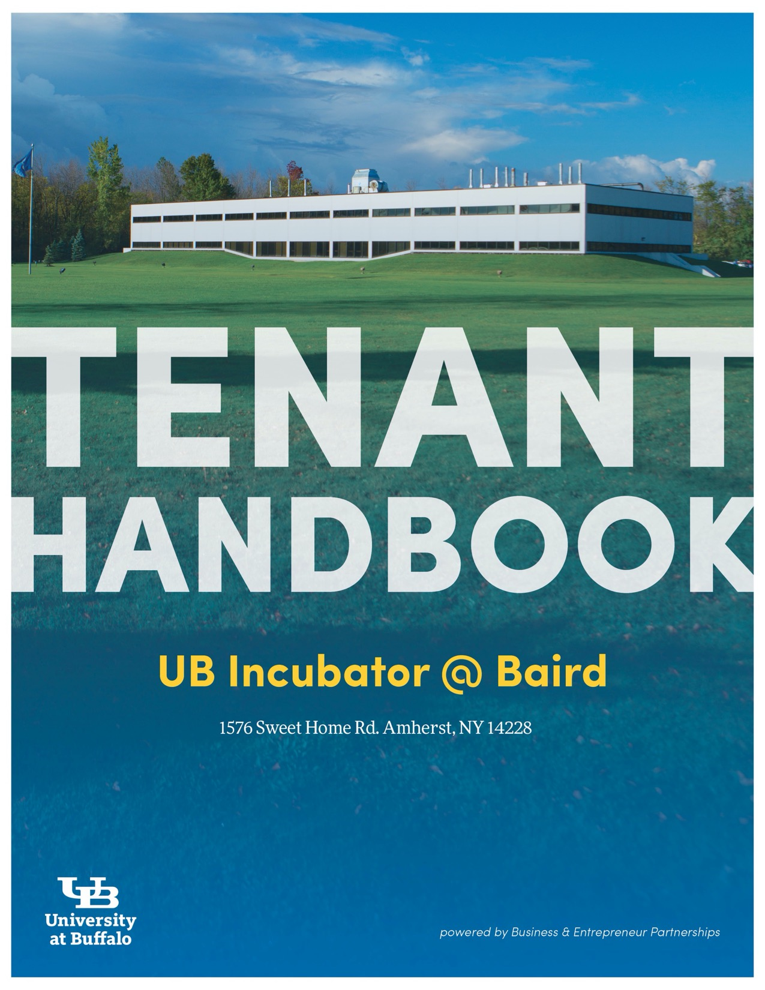

**Client Handbook**

**Table of Contents**

**Client Requirements** 3

**COVID Notice**. 3

**Security** 3

**Diversity and Inclusion** 3

**Office Space** 3

**Tenancy** 3

**Insurance** 4

**Rent** 4

**Client Services** 4

**UB Access – Volunteer Appointments** 4

**Computers/Networks/Device Registration** 5

**Wireless Internet Access** 5

**UB Shuttle** 5

**USPS Mail Delivery/Mailing Address** 5

**Deliveries** 6

**Pick-up** 6

**Office Equipment** 6

**Copier/Printer/Scanner** 6

**Postage Machine** 7

**Telephone Service** 8

**Internet Service** 8

**Idea Lounge** 8

**Co-working Space** 9

**Office Furnishings** 9

**Conference Room Facilities – Room 206/208, 209A** 9

**Room Reservations** 10

**Facilities** 10

**Safety** 10

**Access to Incubator** 11

**Keys/Fobs** 11

**Parking** 12

**Facilities Work Orders** 12

**Janitorial Services** 12

**Trash & Recycling** 12

**Restroom Cleanliness** 12

**Quick Reference Sheet** 13

# **Client Requirements**

## Please note that there are numerous COVID-related notes to each topic. All COVID-related notes dictate any rules set forth in their respective topics. This handbook will be reviewed and updated as appropriate in response to the COVID-19 pandemic.

## **Security**

## Emergency: Contact UB Police at 645-2222

## Non-emergency: Contact UB Police at 645-2222

## 

The UB Police department is the emergency services unit for the UB Incubator at Baird. UB Police will arrange additional responses as appropriate. Please notify Incubator Administration of emergencies as soon as possible, even after the fact.

## **Diversity and Inclusion**

The UB Incubator at Baird is a diverse and safe space for all clients. We encourage ourselves, as well as our clients, to be open, understanding, accommodating and respectful of everyone around us.

## **Office Space**

Some, but not all, of the office spaces at the Incubator at Baird will be furnished. We recommend working with any of the furnishing companies that can be found in our Services Index.

Reasonable modifications may be requested to Incubator Administration for approval. Please note that clients are responsible for all modifications costs and materials, unless stated otherwise. Specific modifications may require assistance from the facilities coordinator.

## **Tenancy**

Once a client is accepted into the UB Incubator program, they must fulfill the following requirements:

*Upon Acceptance*

* The client and UB Foundation Incubator sign a revocable permit
* The client submits a payment for first months’ rent, prior to entering the space
  + Payments can be submitted via a check or credit/debit card
    - Note: rent payments in excess of $999 must be paid via a check
* The client provides Incubator Administration with proof of proper insurance information
* The client signs the Compliance Agreement prior to move-in

*Semi-Annual Updates*

* Clients will meet with members of the Business & Entrepreneur Partnerships support team for semi-annual updates to review progress and assist in business development.
* As agreed to in the Compliance Agreement, clients shall provide, on request:
  + Employee reports
  + Bookkeeper-prepared financial statements

## **Insurance**

All clients are required to obtain and maintain General Liability Insurance in the amount of $1 million as required by the Revocable Permit.

All clients that have employees must also obtain and maintain Workers Compensation Insurance covering the Permittee’s Employees & **Employers Liability**. This coverage will include personal injury, illness or death suffered by anyone during the course of, or on the site of, the operations contemplated by the Permit.

A Certificate of Insurance will be requested as proof of coverage prior to tenancy. Please see the **Baird Insurance Requirement**.

## **Rent**

Rent is due on the first (1st) of each month. Service charges from the previous month will be invoiced to the client and are due at the time of rent. Rent is payable via check delivered to the Incubator offices or online via credit/debit card or via bank transfer.

# **Client Services**

## **UB Access – Volunteer Appointments**

The Incubator at Baird has the ability to submit limited UB volunteer appointments for UB Incubator at Baird affiliated personnel. Volunteer appointments provide individuals with a UBIT name and password used to access UB Secure wireless internet; set up a UB email address; obtain a UB parking pass and a UB ID card. We are happy to submit volunteer appointments for individuals who will benefit from the above, for up to **two people per company**.

Please use the **UB Incubator Affiliates Personnel Form** to request a Volunteer Appointment.

## **Computers/Networks/Device Registration**

Clients must provide their own computers for use in their offices and are responsible for any required maintenance or problems that may occur.

Prior to connecting devices (routers, laptops, PCs, etc.) to the wired internet port, please complete the UB Device Registration Form and submit the completed form to Incubator Administration. Device registration is typically completed within one business day.

## **Wireless Internet Access Points**

Clients and guests can log into *UB_Connect* at the UB Incubator at Baird with any email address. To access *UB_Secure*, a UBIT name and password are required (see the section **UB Access – Volunteer Appointments**on page 4 for eligibility and requirements).

## **UB Shuttle**

**\*COVID Note**: All UB Shuttles are mask mandated. Please be sure to have your mask on before entering the shuttle.

The UB North Campus shuttle runs Monday – Friday from 6:30am to midnight. Students, faculty, staff and visitors on the North Campus now have access to an on-demand campus shuttle.

The service, operated by Parking and Transportation Services, utilizes the TransLoc app that can be downloaded to a cell phone through your app store or found online at transloc.com/app.

Choose your pickup (select **Baird Research Park**) and drop-off locations from a list of North Campus locations shown on the screen. Rides can be scheduled in advance and push notifications will keep you updated as to the shuttle's arrival.

## **USPS Mail Delivery/Mailing Address**

Mail is delivered to the UB Incubator at Baird facility Monday through Friday (excluding holidays). Incubator staff will sort and place the centrally delivered mail directly into your assigned mail slot located in the Business Center. All outgoing mail is the responsibility of the client, including any postage. The drop box for all outgoing mail is located in the Business Center (111).

**All mail for your company should be addressed to:**

**Company Name\***

**Baird Research Park (optional)   
UB Incubator at Baird, Suite # XXX**

**1576 Sweet Home Road**

**Amherst, NY 14228**

**\* Be sure the company name is always included**

## **Deliveries**

**\*COVID Note**: Packages will be delivered directly to clients’ suites who have provided appropriate authorization to Incubator Administration.

USPS, FedEx and UPS all deliver to the UB Incubator at Baird. When ordering packages or scheduling mail delivery, please be sure to include the company name and suite number. Incubator Administration will sign for packages in the client’s absence unless otherwise indicated.

## **Pick-up**

UPS & FedEx both pick up at the UB Incubator at Baird.

**UPS:** The pick up location for small UPS shipments is located outside of suite 102. Larger shipments require pick up at your suite or lab. UPS outgoing packages must be ready for pick up before 4:00 p.m daily. If you have a large outgoing shipment please schedule directly with UPS.

**FedEx:** FedEx only comes for scheduled pick ups. You must schedule a pick up to ensure proper servicing.

## **Office Equipment**

### **Copier/Printer/Scanner**

The copier is located in the Business Center and is a multi-purpose machine used for copying, scanning, faxing and printing. All clients will be provided an access code for the machine. This code allows Incubator Administration to track the number of copies made and pages printed per client.

**Copy machine instructions:**

1. Enter company copy machine code then press OK
2. Place papers in the top section slot of printer
3. Press “Copy” on right hand side of display screen
4. Press “Start” button on pin pad to copy documents

**Scanning instructions:**

1. Enter company copy machine code then press OK
2. Place papers in the top section slot of printer
3. Press “Scan” on right hand side of the display screen
4. Select scan destination then press OK
5. Press “Start” on the pin pad to start scan

**Faxing instructions:**

1. Enter company copy machine code then press OK
2. Place papers in the top section slot of printer
3. Press “Fax” on the right hand side of the display screen
4. Select “Fax number” at top left corner of display screen
5. Type in **1** followed by recipients number
6. Press OK than Start

Any charges made using the client code on either the copy/printer/fax or postage machine will be collected and charged-back to the client company with the next month’s rent. For example, usage from the end of January through the end of February will be calculated and charged with the March rent invoice.

|  |  |
| --- | --- |
| Black and White Copy | $0.05/page |
| Color Copy | $0.10/page |
| Fax – Outgoing | $0.10/page |
| Fax – Incoming | No Charge |
| Scan | No Charge |

### **Postage Machine**

A postage machine is located in the Business Center and is available for clients. This machine supports sending packages up to 5lbs. All clients will be provided an access code. This code allows Incubator Administration to track the amount of postage used by each client.

**Postage machine instructions:**

1. Press the small circular button on the upper right side of the machine
2. Enter company postage code then press OK
3. Place First Class Letter on scale
4. When weight appears press the Green Button to print and slide envelope through bottom section of postage machine
5. Select the Red Button when completed.
6. Press the small circular button to exit out of your company’s code.

**Note:** If envelope is over 13 ounces, you must choose Priority for “Stamp” button menu

1. Enter zip code then press OK
2. Weigh item on scale
3. When weight is displayed press the green button to print
4. If envelope is too large feed in printing labels found in the left hand draw
5. For International Mail
   1. Press “stamp” then choose Wizard *8*
   2. International options start at number 12 for first class
   3. Follow prompts then press OK

For postage, the rates are generally standard rates. Sometimes there is a slight discount for using a postage machine, but this can change with postage rate changes. The cost of posted item(s) is what you will be charged; there is no up-charge.

## **Telephone Service**

Telephone services are the responsibility of client companies. Additional information can be provided by Incubator Administration.

## **Internet Service**

Clients are required to use UB’s Internet service. The Incubator’s internet service is a fully firewalled and secured network. Download speed is roughly 75-100 Mbps and upload speed is roughly 50-75 Mbps. Incubator staff will work with UB CIT to activate a wired connection in your space. This standard internet connection is included as part of the monthly rent.

**Access to the Communication Closet is strictly controlled by UB IT.**

## **Idea Lounge**

**\*COVID Note**: Please wipe down the microwave and coffee maker before and after usage. A cleaning station is available with sufficient cleaning supplies for use in the Idea Lounge.

The Idea Lounge is located on the first floor (Suite 113). It is equipped with a refrigerator, microwave, sink, coffee machine, and various snacks. Coffee and snacks are complimentary for Incubator occupants. If you are hosting a group, please provide your own refreshments. All equipment in the Idea Lounge may be used by client companies and guests. It also serves as an area for informal discussions and meetings. Please be respectful of others in the space and clean-up after yourself.

**Cooking or heating appliances are highly discourged outside of the Idea Lounge.** Incubator Administration works hard to maintain a clean environment for all our clients; please discard any food prior to spoilage. The refrigerator will be cleaned monthly; a notice will be placed on the refrigerator in advance.

## **Co-working Space**

**\*COVID Note**: Co-working has a max capacity of 6 to guarantee social distancing protocols. Please sign in at the entrance of co-working and be sure to wear a mask. To ensure a safe space for all clients’ please wipe down your work space before and after usage with provided cleaning supplies.

The UB Incubators offer affordable co-working space to early-stage entrepreneurs at the UB Incubator at Baird. This space is available to a limited number of people. This space allows clients flexible terms and a variety of basic services. The co-working space has an open floor plan with moveable furniture. It also has a small meeting room that is generally reserved for the use of co-working clients, however on a limited basis, resident clients of the UB Incubator at Baird may utilize the space and/or the meeting rooms for short periods of time.

## **Office Furnishings**

Some spaces come with office furniture and/or cubicles while others do not. The spaces come as is and Incubator Administration is not responsible for providing additional furnishings. Clients will be notified of any surplus furniture that is available for client use.

There are numerous local retail outlets that sell both new and used office furniture and equipment. To inquire with these local retail outlets, please reference our Service Providers Index.

Clients are responsible for all furniture moving. If you are receiving a furniture shipment, please notify a member of the Incubator Team for needed support (i.e., elevator usage, cart usage).

## **Conference Room Facilities – Room 206/208, 209A**

**\*COVID** **Note**: The total occupancy of Conference Room 206/208 is 8 or fewer persons. Please do not rearrange tables, as they have been set up for proper social-distancing protocols. 206/208 may not be booked separately.

Conference Rooms 206 and 208 can be reserved separately or as one**\***. Separately each room comfortably accommodates 10 people and combined they can accommodate up to 25 people in a professional atmosphere. Meeting Room 209A comfortably accommodates 4 people in a casual atmosphere.

A conference telephone is available for use by request to Incubator Administration.

Out of courtesy to other clients, please leave the room as you found it, returning all furniture to its original location(s), disposing of all trash and erasing the white boards.

Reservations are for company use ONLY. To reserve the room for anything other than company use, please connect with Incubator Administration in advance.

## **Conference Room Reservation**

To book a conference room please follow attached link and instructions below:

<https://spacerequest.buffalo.edu/evntwebapp/>

1. Login in with your provided credentials (email address and provided password)
2. Click on “Book Now” next to the reservation template labeled “Request space in the Incubator at Baird (Non-UB)
3. To find a room to book, you will:
   1. Input the dates and times needed for your meeting, and select “Search”
4. Select the room you would like to book by clicked the green + button to the left of the room name.
5. Input the number of attendees, capacity type, and add room
6. Select “Next Step”
7. Input your Event Name
   1. Note: Your Event Name should be the name of your company
8. Select your name as the 1st contact
9. Select “Create Reservation”

Please note that your reservation is **NOT** confirmed when you submit it. Incubator Administration will review the request and either confirm or deny the request within 1 business day.

Should you need to cancel your reservation, please see an Incubator Administrative staff member to complete the cancellation.

# **Facilities**

## **Safety**

Safety is high priority at the Incubator at Baird. Code requirements are maintained as required by UB Environmental Health and Safety and The North Bailey Fire Department. Periodically, Incubator Administration will schedule visits to each space to review them for safety. Below is some general safety information we ask all clients to follow. Please follow the **Fire Code and EHS Safety Regulations** sheet as quick reference and for posting in your spaces.

* Fire Alarm - The Incubator is equipped with a fire alarm system. When activated, the alarms sound directly to the North Bailey Fire Department.
* Please inform all company personnel of the closest stairwell exits in case of an emergency.
* Fire Extinguishers – The building is equipped with fire extinguishers on each floor of the building, meeting all codes and regulations. Individual suites and labs are not required to have a fire extinguisher; however, it is recommended for all laboratories to have a fire extinguisher.
  + Please note that fire extinguishers in individual spaces **must be inspected** internally **monthly** and by a third party **annually**.
* Plug any appliances or equipment directly into an outlet or a surge protector. Do not use extension cords.
* In the event of a power outage, the generator will kick-in approximately 10 seconds after the power goes out. Companies must supply their own UPS (uninterrupted power supply) on all equipment to avoid surges.
  + Once the generator kicks in, it will run on a limited power supply.

## **Access to Baird Research Park**

**\*COVID Note**: Clients are encouraged to have virtual meetings as much as possible and have visitors in the building only when necessary. Visitors must check in with their host company on arrival, and host companies must meet them at the entrance and escort them to the meeting space. Visitors must sign in at the tracking log at the entrance to support potential contact tracing.

The main door and loading dock door are open Monday through Friday from 7:00 a.m. to 6:00 p.m. Incubator doors are not open on weekday holidays. Provided fobs will allow 24-hour building access to clients daily.

If you are expecting visitors during normal business hours please ask them to use the front entrance.

## **Keys/Fobs**

Office keys/fobs allow clients 24/7 access to the Incubator at Baird. Keys/fobs are issued by Incubator Administration, and may NOT be duplicated.

Incubator Staff will issue up to **two** keys and up to **six** fobs per company free of charge. Requests for more fobs beyond six or lost fobs will be available at a fee of **$15.00** per fob. Request for more keys will be available at a fee of **$25.00** per key.

Please submit the UB Incubator Affiliates Personnel Form for each individual requiring a key or fob. When an employee leaves and returns a key/fob to the company, please notify Incubator Management to ensure accurate record keeping.

**Any clients wishing to install security systems for their individual offices must receive prior written approval from Incubator Administration.**

## **Parking**

Free parking is available for all Incubator clients and guests. Appropriate permits are required for accessible spots. Please leave the visitor parking areas open to those visiting the Incubator. Please notify Incubator Management prior to leaving vehicles overnight.

During inclement weather, Incubator Management may communicate special parking restrictions.

## **Facilities Work Orders**

If there are any issues with the building or your space that need attention from facilities, please send an email to Rachel Boruszewski at raborusz@buffalo.edu.

## **Janitorial Services**

**\*COVID Note**: Our janitorial staff continues to clean all areas as appropriate, and specifically focus on high-touch point areas. This includes all door handles, light switches, elevator buttons, handrails, etc. The Incubator Management team will clean the common space areas twice daily.

The UB Incubator at Baird provides janitorial service for all offices and common areas including routine cleaning and trash removal. If you have specific janitorial needs or issues, please contact Incubator Administration.

## **Trash & Recycling**

The UB Incubator at Baird will provide each space with a recycling bin. The Incubator practices All In One recycling (Click link to find out more: **UB All in One Recycling**). Both trash and recycling are collected by janitorial services when the bin is at 50% capacity.

Please break down large cardboard items and place them in the recycling bins located on the loading dock. Janitorial services are **not** responsible for disposal of large cardboard boxes from your space.

## **Restroom Cleanliness**

The restrooms are common space; please wipe down excess water on the sinks and floors and dispose of waste in the appropriate trashcans provided. Please report any issues with restroom cleanliness or operations to Incubator Administration.

# **UB Incubators Quick Reference Sheet**

# **____________________________________________________**

# **UB Incubator at Baird**

**Mailing Address**

Company Name

Baird Research Park

UB Incubator at Baird, Suite #XXX

1576 Sweet Home Road

Amherst, NY 14228-2710

**Fax Number**

716-636-5921

**Building Door Open Hours**

Monday – Friday 7:00AM – 6:00PM  
Doors locked on noted holidays

**Campus Mail**

Company Name

Baird Research Park

Suite #XXX

North Campus

**Conference Room Scheduling Link**

<https://spacerequest.buffalo.edu/evntwebapp/>

**UB Foundation Incubator (UBFI)**

**Insurance Requirements**

As stated in the Permit each Permittee must obtain the following insurances:

* **General Liability**: In the amount of $1,000,000 combined single limit for bodily injury or property damage.
* **Workers Compensation** covering the Permittee’s Employees & **Employers Liability** covering personal injury, illness or death suffered by anyone during the course of, or on the site of, the operations contemplated by the Permit.

**Certificate Requirements**

Please use the following addresses for each respective section. **All Italics must be written exactly as shown on this worksheet.**

* **Insured: (address must be Sweet Home Road)**
  + Name of Company

*1576 Sweet Home Rd*

*Suite* (Your Company’s current suite numbers)

*Amherst, NY 14228*

* **Certificate Holder: (address must be Sweet Home Road)** 
  + *UBF & UBFI*

*1576 Sweet Home Rd*

*Suite 111*

*Amherst, NY 14228*

* **Also Insured: (To be listed in Description of Operations/Locations/Vehicles Section).**
  + *UBF & UBFI* *(Certificate Holder) is named as an additional insured.*
* **Contact Information:**
  + Insurer Contact Name and Phone Number

Incubators Affiliates Personnel Form

This form is to be filled out by anyone affiliated with UB Incubators that needs access to the building, company space and/or a volunteer appointment. The individual is to fill out the following information and have the company CEO or appropriate Incubator staff sign to approve. Only two physical keys per company will be issued.

All information in Section I needs to be completed. Section II only needs to be completed if requesting a volunteer appointment.

Section I – Required

Requesting (check all that apply):   
□ Fob Access   
□ Physical Key for Suite(s)   
□ Volunteer Appointment

Name: _________________________________________________________________

Company: ______________________________________________________________

Company Suite #: ________________________________________________________

Email: _________________________________________________________________

Work Phone #: _________________________________________________________

Cell Phone # : ___________________________________________________________

Section II – Only Required for **Volunteer Appointment** Requests

Job Title: __________________________________________________________________

Brief Job Description: ___________________________________________________________

Person Number # (preferred if applicable): _________________________________

Social Security # (if no person #): _______________________________________

Gender: □ Male □ Female

Date of Birth: ________________________________

Ethnicity: □ American Indian/Alaska Native □ Asian □ Black or African American

□ Native Hawaiian or Other Pacific Islander □ White

Hispanic or Latino: □ Yes □ No

Home Address: ____________________________________________________

Country of Citizenship: _____________________________________________

Visa Type (if applicable): ____________________________________________

Begin Visa Date: _____________________ End Visa Date: _______________________

**NOTE:** Please provide proof of Visa documentation in order to process your appointment.

Volunteer Appointments provide the following; Please check which you need:

□ UBIT Name & Password □ UB Parking Pass □ UB Email Address

□ UB ID Card □ UB Library Access □ UB Secure Wi-Fi (w/EduRoam)

As the Company CEO/Principal or Incubator staff for the above company/organization, I approve the above access request:

_____________________________________________________________________  
Signature & Date

Internal Use Only (staff route the form/info as appropriate and initial and date next to item)   
  
Fob Issued: ________ Pin Issued: _________ Key Issued: _________ VA Submitted: _________ Incutrack: _________



Internal Use Only (staff route the form/info as appropriate and initial and date next to item)   
  
Fob Issued: _______________ Key Issued: ______________ Incutrack:_____________ VA Submitted: ___________



**Fire Code and EH&S Safety Regulations**

*Information for Companies Regarding Fire Code and*

*Environmental Health and Safety Regulations for UB Technology Incubator Spaces*

* If you are going to have fire extinguishers in your space, you need to inspect them monthly and have them inspected by an outside party annually
  + 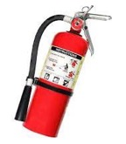It is recommended that laboratories have fire extinguishers. Office spaces it is not necessary
* Extension Cords are not allowed to be plugged into appliances

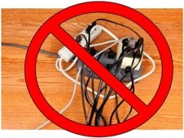(such as microwaves, fridges, water coolers)

➢ Appliances need to be plugged directly into the wall or into a surge protector that is directly plugged into the wall (with no extension cords)

* Space heaters are highly discouraged. They can tip over and catch things one fire. They throw off the heating system. They pose an insurance risk.
  + If you must have a space heater then it needs to be one that has a safety

feature where it auto shuts off at a certain temperature or if it tips over

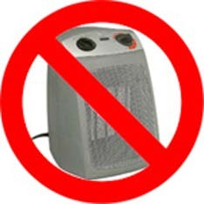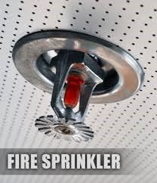

* There must be at least 18” clearance from any sprinklers
* There must be a 36” clearance from electrical panels
* There must be sufficient egress (entry and exit) within the space
* A list of chemicals must be provided to the UB Incubator Staff and MSDS information must be posted in spaces where chemicals are being utilized and /or stored

